Garrett Karolyi
02/16/2026
Module_CH_7
Information Design Systems
Elevator Panel User Interface Evaluation
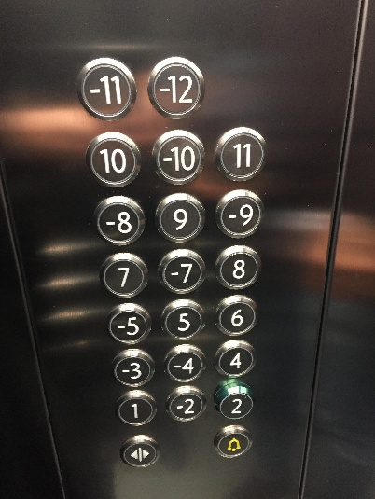
When designing an elevator panel, the focus should be practicality and ease of use. Users should be able to quickly locate their desired floor without having to stop and think about the layout. The interface should follow a predictable and logical order. In the selected panel, the numbering alternates between positive and negative floors, such as 1 followed by -1, then 2 followed by -2. This pattern is confusing and does not match normal users’ expectations. Floors should be arranged sequentially, either ascending or descending, so users can scan naturally. Accessibility is another critical consideration. Braille should be included for visually impaired users, and button height should accommodate individuals of different heights. Emergency features are essential in elevator design, and there should be a clearly visible emergency stop or phone button that stands out. Spacing and lighting also matter because proper spacing reduces accidental presses and good lighting improves readability in low light environments.
The existing panel does meet some basic expectations. The buttons are clearly labeled and visible, which helps with readability. The material also appears durable, which is important in a high traffic environment like an elevator. However, the panel does not logically include all floors in an intuitive way. For example, there is a -12 but no visible positive 12, which raises confusion. It is also difficult to determine from the image whether the buttons illuminate when pressed, which is a common user expectation in modern elevators.
To improve the panel design, floors 1 through 12 should be grouped together in clear ascending order, followed by basement levels from -1 through -12. A clearly labeled Lobby or 0 button should also be included. Adding a distinct red emergency phone or stop button would improve safety and visibility. Simplifying the layout and reorganizing the numbering would make the panel more intuitive, reduce cognitive effort, and better align with standard user expectations.

Reference For Photo
Reddit user. (2017). Elevator button panel [Photograph]. Reddit. https://www.reddit.com/r/CrappyDesign/comments/78gcgt/this_elevator_button_panel/

